Cácphéptoánsốhọctrêncácsốlượngdấu, bù 1, BCD, số Bias
1. Sốlượngdấu
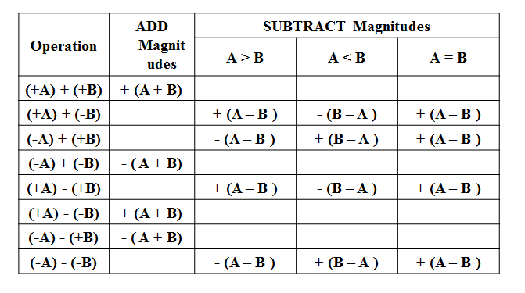
Từđó ta cóthuậttoánsau
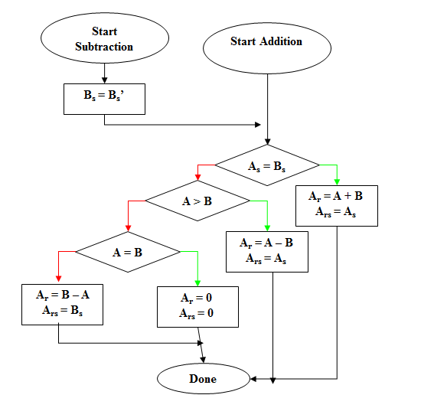
78 – (-5)
A_{s} A_{s}
0100 1110 => 0100 1100
B_{s} B_{s}
-1000 0101 +0000 0101
0101 0011
2. Sốbù 1
Cácbạnthamkhảothuậttoántrongkhungdướiđây:
Adding two values is straight forward. Simply align the values on the least significant bit and add, propagating any carry to the bit one position left. If the carry extends past the end of the word it is said to have "wrapped" around, a condition called an "end-around carry". When this occurs, the bit must be added back in at the right-most bit. This phenomenon does not occur in two's complement arithmetic.
0001 0110 22
+ 0000 0011 3
=========== ====
0001 1001 25
Subtraction is similar, except that borrows are propagated to the left instead of carries. If the borrow extends past the end of the word it is said to have "wrapped" around, a condition called an "end-around borrow". When this occurs, the bit must be subtracted back in at the right-most bit. This phenomenon does not occur in two's complement arithmetic.
0000 0110 6
− 0001 0011 19
=========== ====
1 1111 0011 −12 —An end-around borrow is produced,
- 0000 0001 1 —Subtract the end-around borrow back into the result.
=========== ====
1111 0010 −13 —The correct result (6 − 19 = -13)
It is easy to demonstrate that the bit complement of a positive value is the negative magnitude of the positive value. The computation of 19 + 3 produces the same result as 19 − (−3).
Add 3 to 19.
0001 0011 19
+ 0000 0011 3
=========== ====
0001 0110 22
Subtract −3 from 19.
0001 0011 19
− 1111 1100 −3
=========== ====
1 0001 0111 23 —An end-around borrow is produced.
- 0000 0001 1 —Subtract the end-around borrow back into the result.
=========== ====
0001 0110 22 —The correct result (19 - (-3) = 22).
Thamkhảo: http://en.wikipedia.org/wiki/Ones'_complement
78 – (-5)
0100 1110
-1111 1010
1 0101 0100
- 0000 0001
0101 0011
3. SốBCD
Cácbạnthamkhảothuậttoántrongkhungdướiđây

BCD Addition
Either packed or unpacked BCD numbers can be summed. BCD addition follows the same rules as binary addition. However, if the addition produces a carry and/or creates an invalid BCD number, an adjustment is required to correct the sum. The correction method is to add 6 to the sum in any digit position that has caused an error.
Vídụ
24 + 13 = 37 |  |  |  | 15 + 9 = 24 |  |  |  |  | 19 + 28 = 47
0010 0100 | = | 24 |  | 0001 0101 | = | 15 |  |  | 0001 1001 | = | 19
+ 0001 0011 | = | 13 |  | + 0000 1001 | = | 9 |  |  | + 0010 1000 | = | 28
0011 0111 | = | 37 |  | 0001 1110 | = | 1? | (invalid) |  | 0100 0001 | = | 41 | (error)
 |  |  |  | 0001 1110 | = | 1? | (invalid) |  | 0100 0001 | = | 41 | (error)
 |  |  |  | + 0000 0110 | = | 6 | (adjustment) |  | + 0000 0110 | = | 6 | (adjustment)
 |  |  |  | 0010 0100 | = | 24 |  |  | 0100 0111 | = | 47
BCD Subtraction
Either packed or unpacked BCD numbers can be subtracted. BCD subtraction follows the same rules as binary subtraction. However, if the subtraction causes a borrow and/or creates an invalid BCD number, an adjustment is required to correct the answer. The correction method is to subtract 6 from the difference in any digit position that has caused an error.

Vídụ
37 - 12 = 25 |  |  |  | 65 - 19 = 46 |  |  |  |  | 41 - 18 = 23
0011 0111 | = | 37 |  | 0110 0101 | = | 65 |  |  | 0100 0001 | = | 41
- 0001 0010 | = | 12 |  | - 0001 1001 | = | 19 |  |  | - 0001 1000 | = | 18
0010 0101 | = | 25 |  | 0100 1100 | = | 4? | (invalid) |  | 0010 1001 | = | 29 | (error)
 |  |  |  | 0100 1100 | = | 4? | (invalid) |  | 0010 1001 | = | 29 | (error)
 |  |  |  | - 0000 0110 | = | 6 | (adjustment) |  | - 0000 0110 | = | 6 | (adjustment)
 |  |  |  | 0100 0110 | = | 46 |  |  | 0010 0011 | = | 23
Thamkhảothêmtại link sau: http://academic.evergreen.edu/projects/biophysics/technotes/program/bcd.htm
78 – (-5)
0000 0111 1000
-1001 1001 0101
0110 1110 0011
-0110 0110 0000
0000 1000 0011
4. Số Bias
Bias Addition
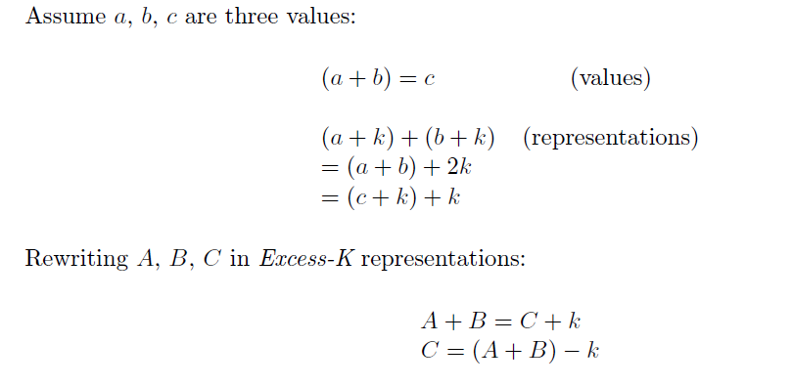

Thamkhảothêmlink sau: http://www.cs.auckland.ac.nz/~patrice/210-2006/210%20LN04_2.pdf
78 – (-5)
1100 1101
-0111 1010
0101 0011
+0111 1111
1101 0010

